A point must satisfy both the equation and condition, then these points are said to be elliptic curve cryptography.

So(2,4) is said to be elliptic curve cryptography.

(x,y) 🡪 can be a real number, complex number or a finite field also.

All the points plotted, will look like this curve.

# **Types of Elliptic Curve**

# **Elliptic Curve over Finite Field**

We are going to construct an elliptical curve where the values of x and y will be from a finite field.

Set of all integers under mod 11.

This is the modular arithmetic property.

# **Construct an Elliptic Curve over a Finite Field Z/11**

With this equation, we are going to find all our points that are used to construct a elliptic curve over a finite field Z/11.

## **Finding the points**

So we have successfully identified all our points to form an elliptic curve that was constructed over set of all integers mod 11.

## **Plotting the points**

## **Check if a point falls on the curve**

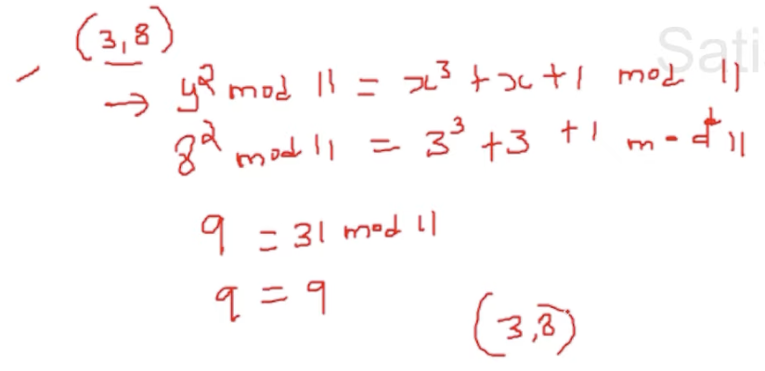

These are the points which fall on a elliptic curve.

## **Adding two points on a curve**

What is P+Q provided (P!=Q) ?

1. Draw a straight line joining P and Q.
2. The line intersects the curve at a point.
3. Opposite to that point on the X-axis is P+Q (i.e R).

### **Going to find R in a method**

Going to find R(x3,y3).  
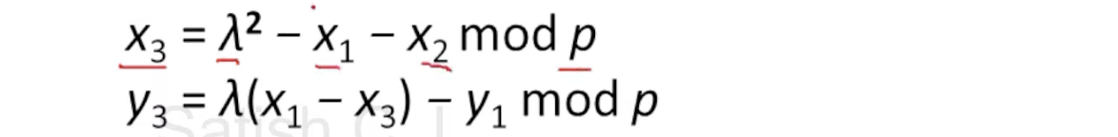

What is lambda ??

Lets see an example, We can find the third point(R) by adding P and Q. [P!=Q and Q!= - P]

### **Checking R(x3, y3**

Now (x3, y3) = (3,3).  
Lets check whether the points (3,3) lie on the elliptical curve or not ??  
